**That component which accepts a component as a prop and returns a component.**

**e.g., ↓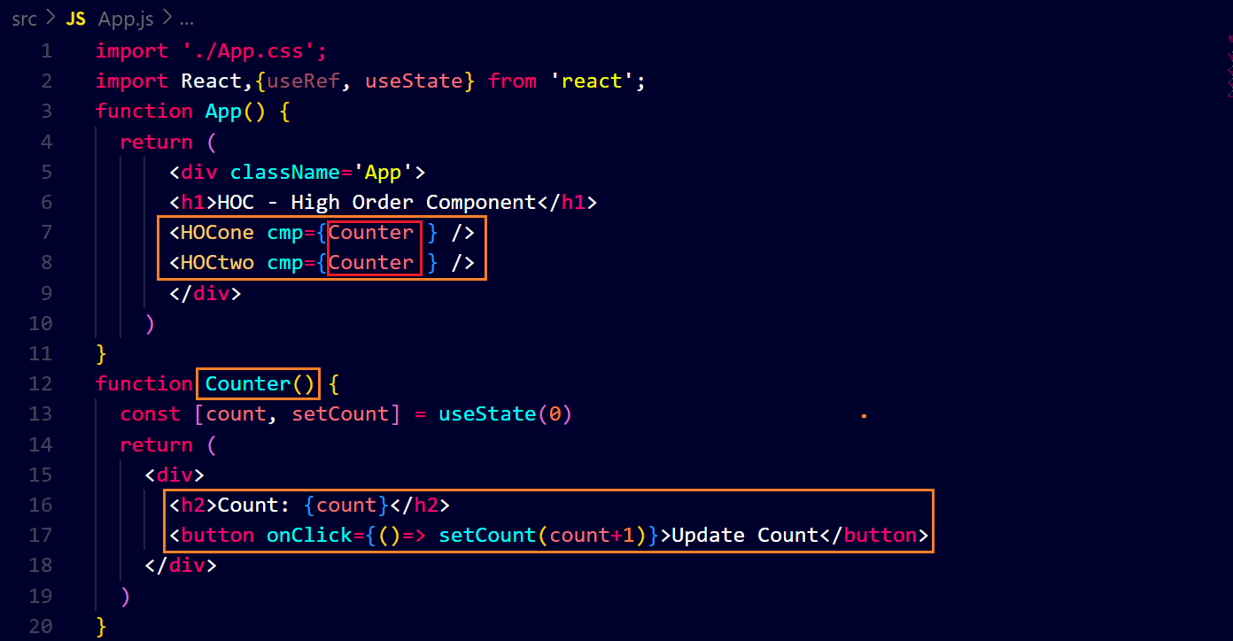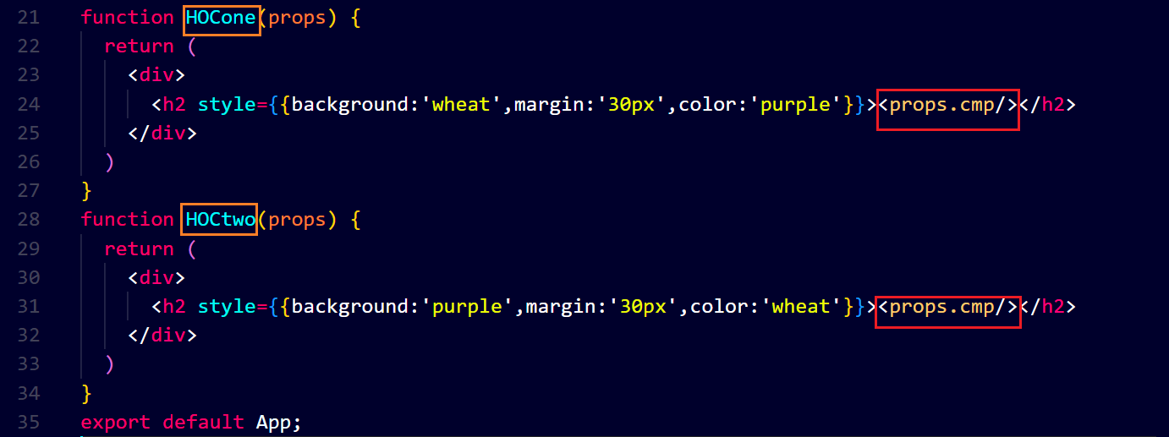output ↓**